**Online Job**

**System Requirements Specification(SRS)**

|  |  |
| --- | --- |
| **#** | **Team Member** |
| 1 | Esraa Salah Eldeen Abdou Zidane |
| 2 | Al-Tahir Muhammad Al-Tahir |
| 3 | Ahmed Azzam Ali Rady |
| 4 | Saif Mohamed Ismaeel |

**Functional Requirements**

**1 User Registration and Authentication**

**1.1 User(Job seeker or The Employer) register by his personal information like his name, mobile, address and email.**

**1.2 User verify his account by email,and he specify if he is an employee or job seeker.**

**2 Manage Profile**

**2.1 Job seeker add his name, address, email, mobile, photo and his job title to his profile.**

**2.2 Job seeker upload his CV to the profile.**

**3 Job Posting**

**3.1 Employer post jobs**

**3.1 Employer specify description, requirements, and skills for each job.**

**4 Job Search**

**4.1 Job seeker search for his job title, or any other job.**

**4.2 Job seeker filter the jobs by date post, experience, and job type.**

**5 Apply Job**

**5.1 Job seekers apply for any job by submitting job applications.**

**5.2 Job seekers uploading their CV’s.**

**6 ATS**

**6.1 The system has its ATS system to help employees to filter CVs and choose best of them.**

**6.2 If the Employer doesn't want to make the system filter CVs, the system will choose all applicants.**

**7 Make an appointment with the candidate**

**7.1 The Employer make an appointment with the candidate whom he has selected by mark application as ready for interview or rejected.**

**8 Communicate with the candidate**

**8.1 The Employer communicate with the candidates who has selected.**

**2.Non-Functional Requirements**

**2.1 Performance**

**Response Time: Specify the maximum acceptable time for the system to respond to user interactions.**

**2.2 Scalability**

**Load Balancing: If applicable, describe how the system will distribute incoming traffic across multiple servers to ensure balanced load.**

**Database Scalability: Outline the strategy for scaling the database to accommodate increased data and user growth.**

**2.3 Security**

**Authentication and Authorization: Specify requirements for user authentication and authorization mechanisms to ensure that only authorized users can access certain features or data.**

**2.4 Usability**

**User Interface Responsiveness: Specify the expected responsiveness and user experience of the system's interfaces.**

**Accessibility: Ensure that the system is designed to be accessible to users with disabilities, conforming to relevant accessibility standards.**

**2.5 Maintainability**

**Code Maintainability: Specify coding standards and practices that facilitate ease of maintenance for developers.**

**2.6 Documentation**

**Documentation: Describe the level of documentation required for the codebase, APIs, and system architecture.**

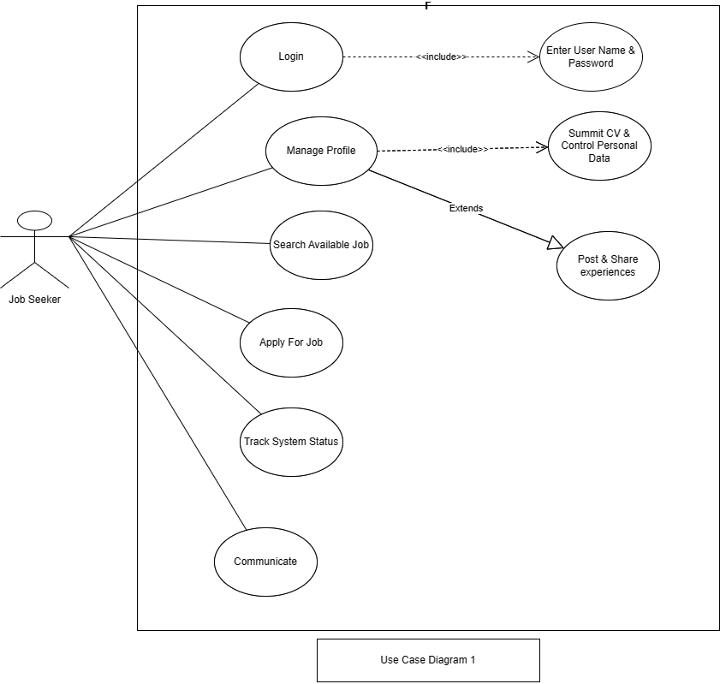

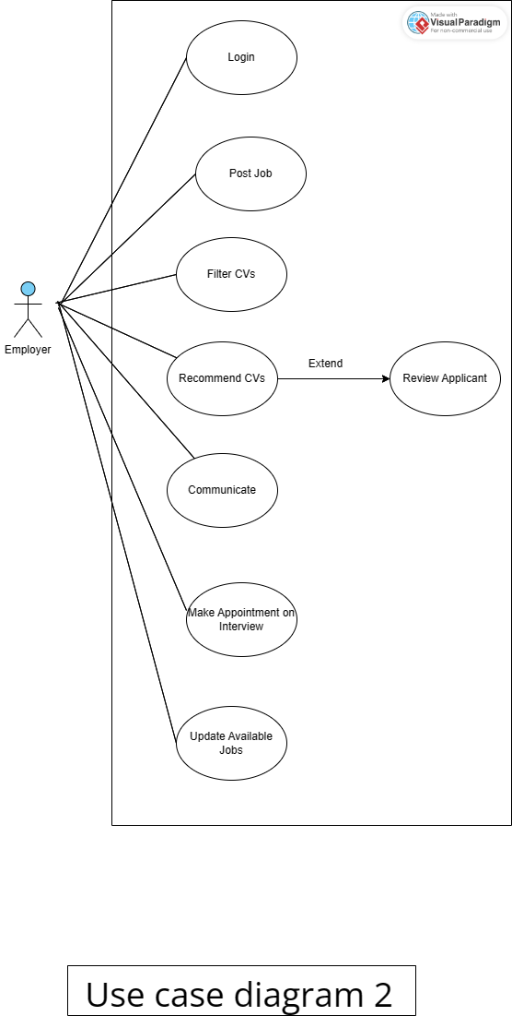

Use Case Scenario 1

|  |  |
| --- | --- |
| **Name: Applying for a Job** |  |
| **Actor: Job Seeker** |  |
| **Entry Condition: The job seeker must log into the system. The job listing is available and accessible to the job seeker.** |  |
| **Exit Condition: The application is successfully submitted to the employer. The job seeker receives a confirmation message.** |  |
| **Flow Of Events:**   1. **After the seeker make login into system.** 2. **The job seeker can manage his profile and submit the CV on the**   **system (control it’s data).**   1. **The system displays a list of job openings (Browse Job Listings), categorized by industries, positions, salaries, and locations.** 2. **The job seeker may filter the list by best option.** 3. **The job seeker selects a job listing after filtering to view detailed information.** 4. **The job seeker reviews the job details and decides to apply.** 5. **The system gives the job seeker an application to submit, attaching necessary documents (CV, etc.).** 6. **The job seeker confirms the application submission.** 7. **The job seeker receives a confirmation email with details of the submitted application.** 8. **The seeker can track its application.** |  |
| **Alternative Events**  **If the job seeker encounters an issue during the process, an error message is displayed, and the user should correct the information.** |  |

|  |  |
| --- | --- |
| **Name: Review the Applications** |  |
| **Actor: The Employer** |  |
| **Entry Condition:**   * **The employer is logged into the system.** * **There are job applications available for review.** * **There are seekers apply to the application** |  |
| **Exit Condition:**   * **The employer has reviewed the applications and made decisions for each.** * **Communication with selected job seekers is facilitated through the messaging system.** |  |
| **Flow Of Events:**   1. **The employer navigates to the Review Applications**. 2. **The system presents a list of job applications.** 3. **The employer filters the applications and sorts it by qualifications and submission date.** 4. **The employer selects a specific application to view the Seeker profile.** 5. **The system displays the Seeker CV.** 6. **The employer reviews the applicant's information.** 7. **The employer marks the application status as Ready for Interview or Rejected** 8. **The employer communicates with a ready for interview candidate using the messaging system.** |  |
| **Alternative Events**  **I f the employer decides to modify the job posting details after reviewing applications, the system allows for easy updates and informs applicants about any changes.** |  |

Use Case Scenario 2 (in detail)

|  |  |  |
| --- | --- | --- |
| **Use case name** | Login | |
| **Unique ID** | Online job-job seeker-001 | |
| **Area** | Application | |
| **Actor(s)** | Job Seeker | |
| **Description** | Job Seeker login to his account | |
| **Triggering Event** | Job Seeker click “Login” button in the application | |
| **Preconditions** | * The Job Seeker needs to download application then open it * The Job Seeker needs to have internet access * The Job Seeker needs to have account | |
| **Postconditions** | - Job Seeker has successfully logged in to his account | |
| **Assumptions** | * Job Seeker have Job application * A valid data | |
| **Steps Performed** | | **Information for Steps** |
| 1. Open application 2. Job Seeker enters his data 3. Click on “Login” button 4. Validation of entered data by application | | Step 2: E-mail, Password |
| **Extensions**  **(Alternative Flows)** | - If user entered a non-valid data, a warning message should  appear to him | |

**Table 1. Login for Job Seeker Use Case Description**

|  |  |  |
| --- | --- | --- |
| **Use case name** | Login | |
| **Unique ID** | Online job-job seeker-001 | |
| **Area** | Application | |
| **Actor(s)** | Employer | |
| **Description** | Employer login to his account | |
| **Triggering Event** | Employer click “Login” button in the application | |
| **Preconditions** | * The Employer needs to download application then open it * The Employer needs to have internet access * The Employer needs to have account | |
| **Postconditions** | - Employer has successfully logged in to his account | |
| **Assumptions** | * Employer have Job application * A valid data | |
| **Steps Performed** | | **Information for Steps** |
| 1. Open application 2. Employer enters his data 3. Click on “Login” button 4. Validation of entered data by application | | Step 2: E-mail, Password |
| **Extensions**  **(Alternative Flows)** | - If Employer entered a non-valid data, a warning message should  appear to him | |

**Table 2. Login for Employer Use Case Description**

|  |  |  |
| --- | --- | --- |
| **Use case name** | Manage profile | |
| **Unique ID** | Online Job- Job seeker -002 | |
| **Area** | Application | |
| **Actor(s)** | Job Seeker | |
| **Description** | Job Seeker manage his profile | |
| **Triggering Event** | Job Seeker click “Add CV” button in the  Application | |
| **Preconditions** | - The Job seeker needs to login in to his account | |
| **Postconditions** | - Job Seeker has successfully added his data to his  Account | |
| **Assumptions** | * Job Seeker have online job application * A valid data | |
| **Steps Performed** | | **Information for Steps** |
| 1- Open application 2- Job seeker log in  3- Job seeker click “Summit CV” button   1. Job seeker Enters his data 2. Job seeker post & share experiences 3. Job seeker clicks on “Save” button 4. Validation of entered data by application | | Step 2: E-mail, Password Step 3: CV, Personal Data |
| **Extensions (Alternative Flows)** | - If the Job Seeker entered a non valid information , error message Appear to him | |

**Table 3. Manage Profile Use Case Description**

|  |  |  |
| --- | --- | --- |
| **Use case name** | Search for an Available Job | |
| **Unique ID** | Online Job - Job Seeker -003 | |
| **Area** | Application | |
| **Actor(s)** | Job Seeker | |
| **Description** | Job Seeker Search Available Job | |
| **Triggering Event** | Job Seeker click “Search Available Job” button in the  Application | |
| **Preconditions** | - The Job Seeker needs to login in to his account | |
| **Postconditions** | - Job Seeker has Successfully Search Available Job | |
| **Assumptions** | * Job Seeker have Online Job Application * A valid data | |
| **Steps Performed** | | **Information for Steps** |
| 1. Open application 2. Job Seeker log in 3. Click “Available Jobs” list 4. Appear list of Jobs categorized by job details 5. Job Seeker may filter the list by best option 6. Click “Best Option” button | | Step 2: E-mail, Password Step 3: Available Jobs  Step 4:Job detailslike: industries, industries, positions, salaries, and locations. |
| **Extensions**  **(Alternative Flows)** | - - If the Job Seeker entered a non valid information , error message Appear to him | |

**Table 4.** **Search for an Available Job Use Case Description**

|  |  |  |
| --- | --- | --- |
| **Use case name** | Apply for job | |
| **Unique ID** | Online Job - Job Seeker -004 | |
| **Area** | Application | |
| **Actor(s)** | Job Seeker | |
| **Description** | Job Seeker Applying for a Job | |
| **Triggering Event** | Job Seeker click “Applying for Job” button in the application | |
| **Preconditions** | - Job Seeker needs to login in to his account | |
| **Postconditions** | Job Seeker has successfully applied for a Job | |
| **Assumptions** | * Job Seeker have Online Job application * A valid data | |
| **Steps Performed** | | **Information for Steps** |
| 1- Open application  2- Job Seeker log in  3- Job Seeker click “Available Jobs” list  4- Job Seeker choose one job   1. Job Seeker click “Applying for Job” button | | Step 1: E-mail, Password  Step 3:Job details  Step 4:Choosen job |
| **Extensions (Alternative Flows)** | - If user doesn't choose any job, warning message should appear to him | |

**Table 5. Apply for job Use Case Description**

|  |  |  |
| --- | --- | --- |
| **Use case name** | Track System(Application) Status | |
| **Unique ID** | Online Job- Job Seeker -005 | |
| **Area** | Application | |
| **Actor(s)** | Job Seeker | |
| **Description** | Job Seeker can track its application | |
| **Triggering Event** | Job Seeker click on “Track” button in the application | |
| **Preconditions** | - The Job Seeker needs to login in to his account | |
| **Postconditions** | - Job Seeker has successfully tracked its application | |
| **Assumptions** | * Job Seeker has Online Job application | |
| **Steps Performed** | | **Information for**  **Steps** |
| 1. Open application   2- Job Seeker log in   1. Job Seeker click on “Track” button in the application | | Step 1: E-mail, Password  Step 3:Job details  Step 4:Choosen job |
| **Extensions (Alternative Flows)** | - If Job Seeker entered a non-valid data in login, a warning message should appear to him | |

**Table 6. Track System(Application) Status Use Case Description**

|  |  |  |
| --- | --- | --- |
| **Use case name** | Post Job | |
| **Unique ID** | Online Job-Employer-006 | |
| **Area** | Application | |
| **Actor(s)** | Employer | |
| **Description** | Employer post the jobs needed applicants | |
| **Triggering Event** | User click “post job” button in the application | |
| **Preconditions** | - The Employer needs to login in to his account | |
| **Postconditions** | - The Employer has successfully post job in the application | |
| **Assumptions** | * Employer have Online Job application * Employer should post job require applicants | |
| **Steps Performed** | | **Information for Steps** |
| 1. Open application   2.Employer log in  3.Employer entered Job require applicant  4. Employer entered Job qualifications  4.Validation of entered data by application  5.Employer click “post job” button | | Step 1: E-mail, Password Step 6 : Job require applicants  Step 6: Job details |
| **Extensions**  **(Alternative Flows)** | - If Employer entered a non-valid data, a warning message  should appear to him | |

**Table 7. Post Job Use Case Description**

|  |  |  |
| --- | --- | --- |
| **Use case name** | Update Available Jobs | |
| **Unique ID** | Online Job-Employer-007 | |
| **Area** | Application | |
| **Actor(s)** | Employer | |
| **Description** | Employer update available jobs | |
| **Triggering Event** | Employer click “update” button in the application | |
| **Preconditions** | - The Employer needs to login in to his account | |
| **Postconditions** | - The Employer has successfully update available jobs | |
| **Assumptions** | * Employer have Online Job application * Employer should update available jobs | |
| **Steps Performed** | | **Information for Steps** |
| 1. Open application   2.Employer log in  3.Employer entered Job that require applicant  4. Employer entered Job qualifications  4.Validation of entered data by application  5.Employer click “update available jobs” button | | Step 1: E-mail, Password Step 6 : Job require applicants  Step 6: Job details |
| **Extensions**  **(Alternative Flows)** | - If Employer entered a non-valid data, a warning message  should appear to him | |

**Table 8. Update Available Jobs Use Case Description**

|  |  |  |
| --- | --- | --- |
| **Use case name** | Filter CVs | |
| **Unique ID** | Online Job-Employer-008 | |
| **Area** | Application | |
| **Actor(s)** | Employer | |
| **Description** | Employer Filter CVs | |
| **Triggering Event** | Employer click “show CVs” button in the application | |
| **Preconditions** | - The Employer needs to login in to his account | |
| **Postconditions** | - The Employer has successfully Filter CVs | |
| **Assumptions** | * Employer have Online Job application * Employer should update available jobs | |
| **Steps Performed** | | **Information for Steps** |
| 1. Open application   2.Employer log in  3.Employer entered Job that require applicant  4. Employer entered Job qualifications  5.Validation of entered data by application  6.Employer click “show Cvs” button | | Step 1: E-mail, Password Step 6 : Job require applicants  Step 6: Job details  Step 7: Cvs |
| **Extensions**  **(Alternative Flows)** | - If Employer entered a non-valid data, a warning message  should appear to him | |

**Table 9. Filter CVs Use Case Description**

|  |  |  |
| --- | --- | --- |
| **Use case name** | Recommend CVs | |
| **Unique ID** | Online Job-Employer-009 | |
| **Area** | Application | |
| **Actor(s)** | Employer | |
| **Description** | Employer Recommend CVs | |
| **Triggering Event** | Employer click “recommend CVs” list in the application | |
| **Preconditions** | - The Employer needs to login in to his account | |
| **Postconditions** | - The Employer has successfully u Recommend CVs | |
| **Assumptions** | * Employer have Online Job application * Employer should review Applicants | |
| **Steps Performed** | | **Information for Steps** |
| 1. Open application   2.Employer log in  3.Employer entered Job that require applicant  4. Employer entered Job qualifications  5.Validation of entered data by application | | Step 1: E-mail, Password Step 6 : Job require applicants  Step 6: Job details  Step 7: Best Cvs |
| **Extensions**  **(Alternative Flows)** | - If Employer entered a non-valid data, a warning message  should appear to him | |

**Table 10. Recommend CVs Use Case Description**

|  |  |  |
| --- | --- | --- |
| **Use case name** | Make appointment on interview | |
| **Unique ID** | Online Job-Employer-010 | |
| **Area** | Application | |
| **Actor(s)** | Employer | |
| **Description** | Employer make appointment on interview | |
| **Triggering Event** | Employer click “accept” button in the application | |
| **Preconditions** | - The Employer needs to login in to his account | |
| **Postconditions** | - The Employer has successfully make appointment on interview | |
| **Assumptions** | * Employer have Online Job application * Employer should update available jobs | |
| **Steps Performed** | | **Information for Steps** |
| 1. Open application   2.Employer log in  3.Employer entered Job that require applicant  4. Employer entered Job qualifications  4.Validation of entered data by application  5.Employer click “Accept” button | | Step 1: E-mail, Password Step 6 : Job require applicants  Step 6: Job details  Step 7:Appointment |
| **Extensions**  **(Alternative Flows)** | - If Employer entered a non-valid data, a warning message  should appear to him | |

**Table 11. Make appointment on interview Use Case Description**

|  |  |  |
| --- | --- | --- |
| **Use case name** | Communicate | |
| **Unique ID** | Online Job-Employer-011 | |
| **Area** | Application | |
| **Actor(s)** | Job seeker | |
| **Description** | Job seeker Communicate with company | |
| **Triggering Event** | Job seeker click “Communicate” button in the application | |
| **Preconditions** | - Job seeker needs to login in to his account | |
| **Postconditions** | - The Job seeker has successfully Communicate with company | |
| **Assumptions** | * Employer have Online Job application * Employer Accept the Job seeker | |
| **Steps Performed** | | **Information for Steps** |
| 1. Open application   2. Job Seeker log in  3.Employer entered Job that require applicant  4. Employer entered Job qualifications 5.Validation of entered data by application  6.Job seeker click “Communicate” button | | Step 1: E-mail, Password Step 6 : Job require applicants  Step 6: Job details  Step 11:contact_no |
| **Extensions**  **(Alternative Flows)** | - If Job seeker entered a non-valid data, a warning message  should appear to him | |

**Table 12 Communicate with company Use Case Description**

|  |  |  |
| --- | --- | --- |
| **Use case name** | Communicate | |
| **Unique ID** | Online Job-Employer-012 | |
| **Area** | Application | |
| **Actor(s)** | Employer | |
| **Description** | Employer Communicate with Job Seeker | |
| **Triggering Event** | Employer click “send acception” button in the application | |
| **Preconditions** | - The Employer needs to Accept the Job Seeker | |
| **Postconditions** | - The Employer has successfully Communicate with Job Seeker | |
| **Assumptions** | * Employer have Online Job application * Employer should accept the Job Seeker | |
| **Steps Performed** | | **Information for Steps** |
| 1. Open application   2.Employer log in  3.Employer entered Job that require applicant  4. Employer entered Job qualifications  4.Validation of entered data by application  5.Employer click “send acception” button | | Step 1: E-mail, Password Step 6 : Job require applicants  Step 6: Job details  Step 11:contact_no |
| **Extensions**  **(Alternative Flows)** | - If Employer entered a non-valid data, a warning message  should appear to him | |

**Table 13. Communicate with Job seeker Use Case Description**

